This Photo by Unknown Author is licensed under CC BY-NC | Supper
 | 2022
Sunday | Monday | Tuesday | Wednesday | Thursday | Friday | Saturday
 |  |  |  | 1 | 2 | 3
 | 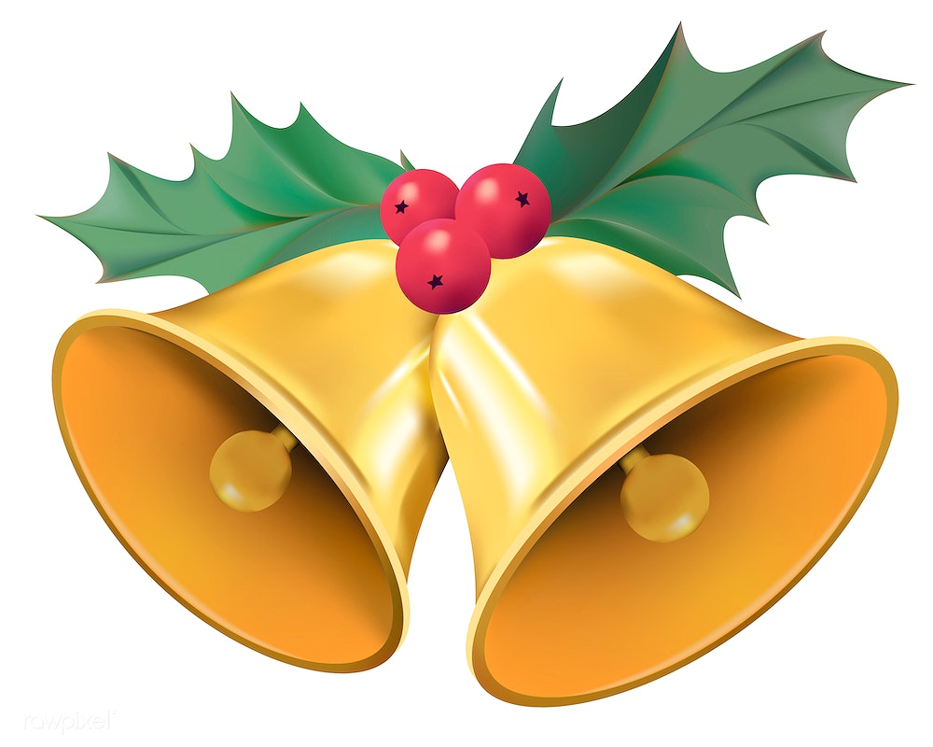 |  |  | Roast Chicken  Roasted Potatoes  Veggies | Hamburger Steak  Mashed Potatoes  Corn | Ham  Scalloped Potatoes  Green Beans
4 | 5 | 6 | 7 | 8 | 9 | 10
Chicken Parmesan  Fettucine Alfredo  Vegetables  Bread | Honey Garlic  Beef stir-fry  Noodles | Mushroom Pork Chops  Mashed Potatoes  Mix veggies | Farmer Sausage  Beans  w/fried onion gravy  Mixed veggies | S&S Chicken Balls  Fried Rice | Veal  Mashed Potatoes  Veggies | Chicken Cordon Bleu  Mashed Potatoes  Veggies
11 | 12 | 13 | 14 | 15 | 16 | 17
Sloppy Joes  Fried Potatoes  Coleslaw | Turkey  Meatballs  Mashed Potatoes/ Corn  Stuffing | Basa Fish  Fries  Coleslaw | Spaghetti  & Meat Sauce  Garlic Bread | Ham  Mac & Cheese  Broccoli salad | Chicken Fingers  French Fries  Coleslaw | Farmer Sausage  Keilke  Veggies
18 | 19 | 20 | 21 | 22 | 23 | 24
Hot Turkey Sandwich  French Fries  Veggies | S&S Meatballs  Rice  Coleslaw | Riblets  Fries  Salad | Chicken Stir Fry  Rice | Pizza  Ham & Pineapple  Meat lovers  Salad | Sausage  Perogies  Cream Gravy  Veggies | KFC Chicken  Mashed Potatoes  Mixed Veggies
25 | 26 | 27 | 28 | 29 | 30 | 31
Ham on Bone  Mashed Potatoes  Carrots  Apple sauce | Pork Ribs  Roast Potatoes  Veggies | Waffle Night  Strawberry Sauce  B-F Sausage | Raisin Chicken Legs  Bubbat  Mashed Potatoes  Veggies | Chef Salad  Garlic Bread  Soup | Fish Burger  Onion Rings  Coleslaw | Beef Stew  Cheddar Biscuit

