October Supper
2022
Sunday | Monday | Tuesday | Wednesday | Thursday | Friday | Saturday
 |  |  |  |  |  | 1
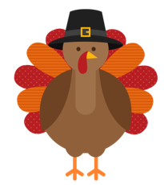 |  | 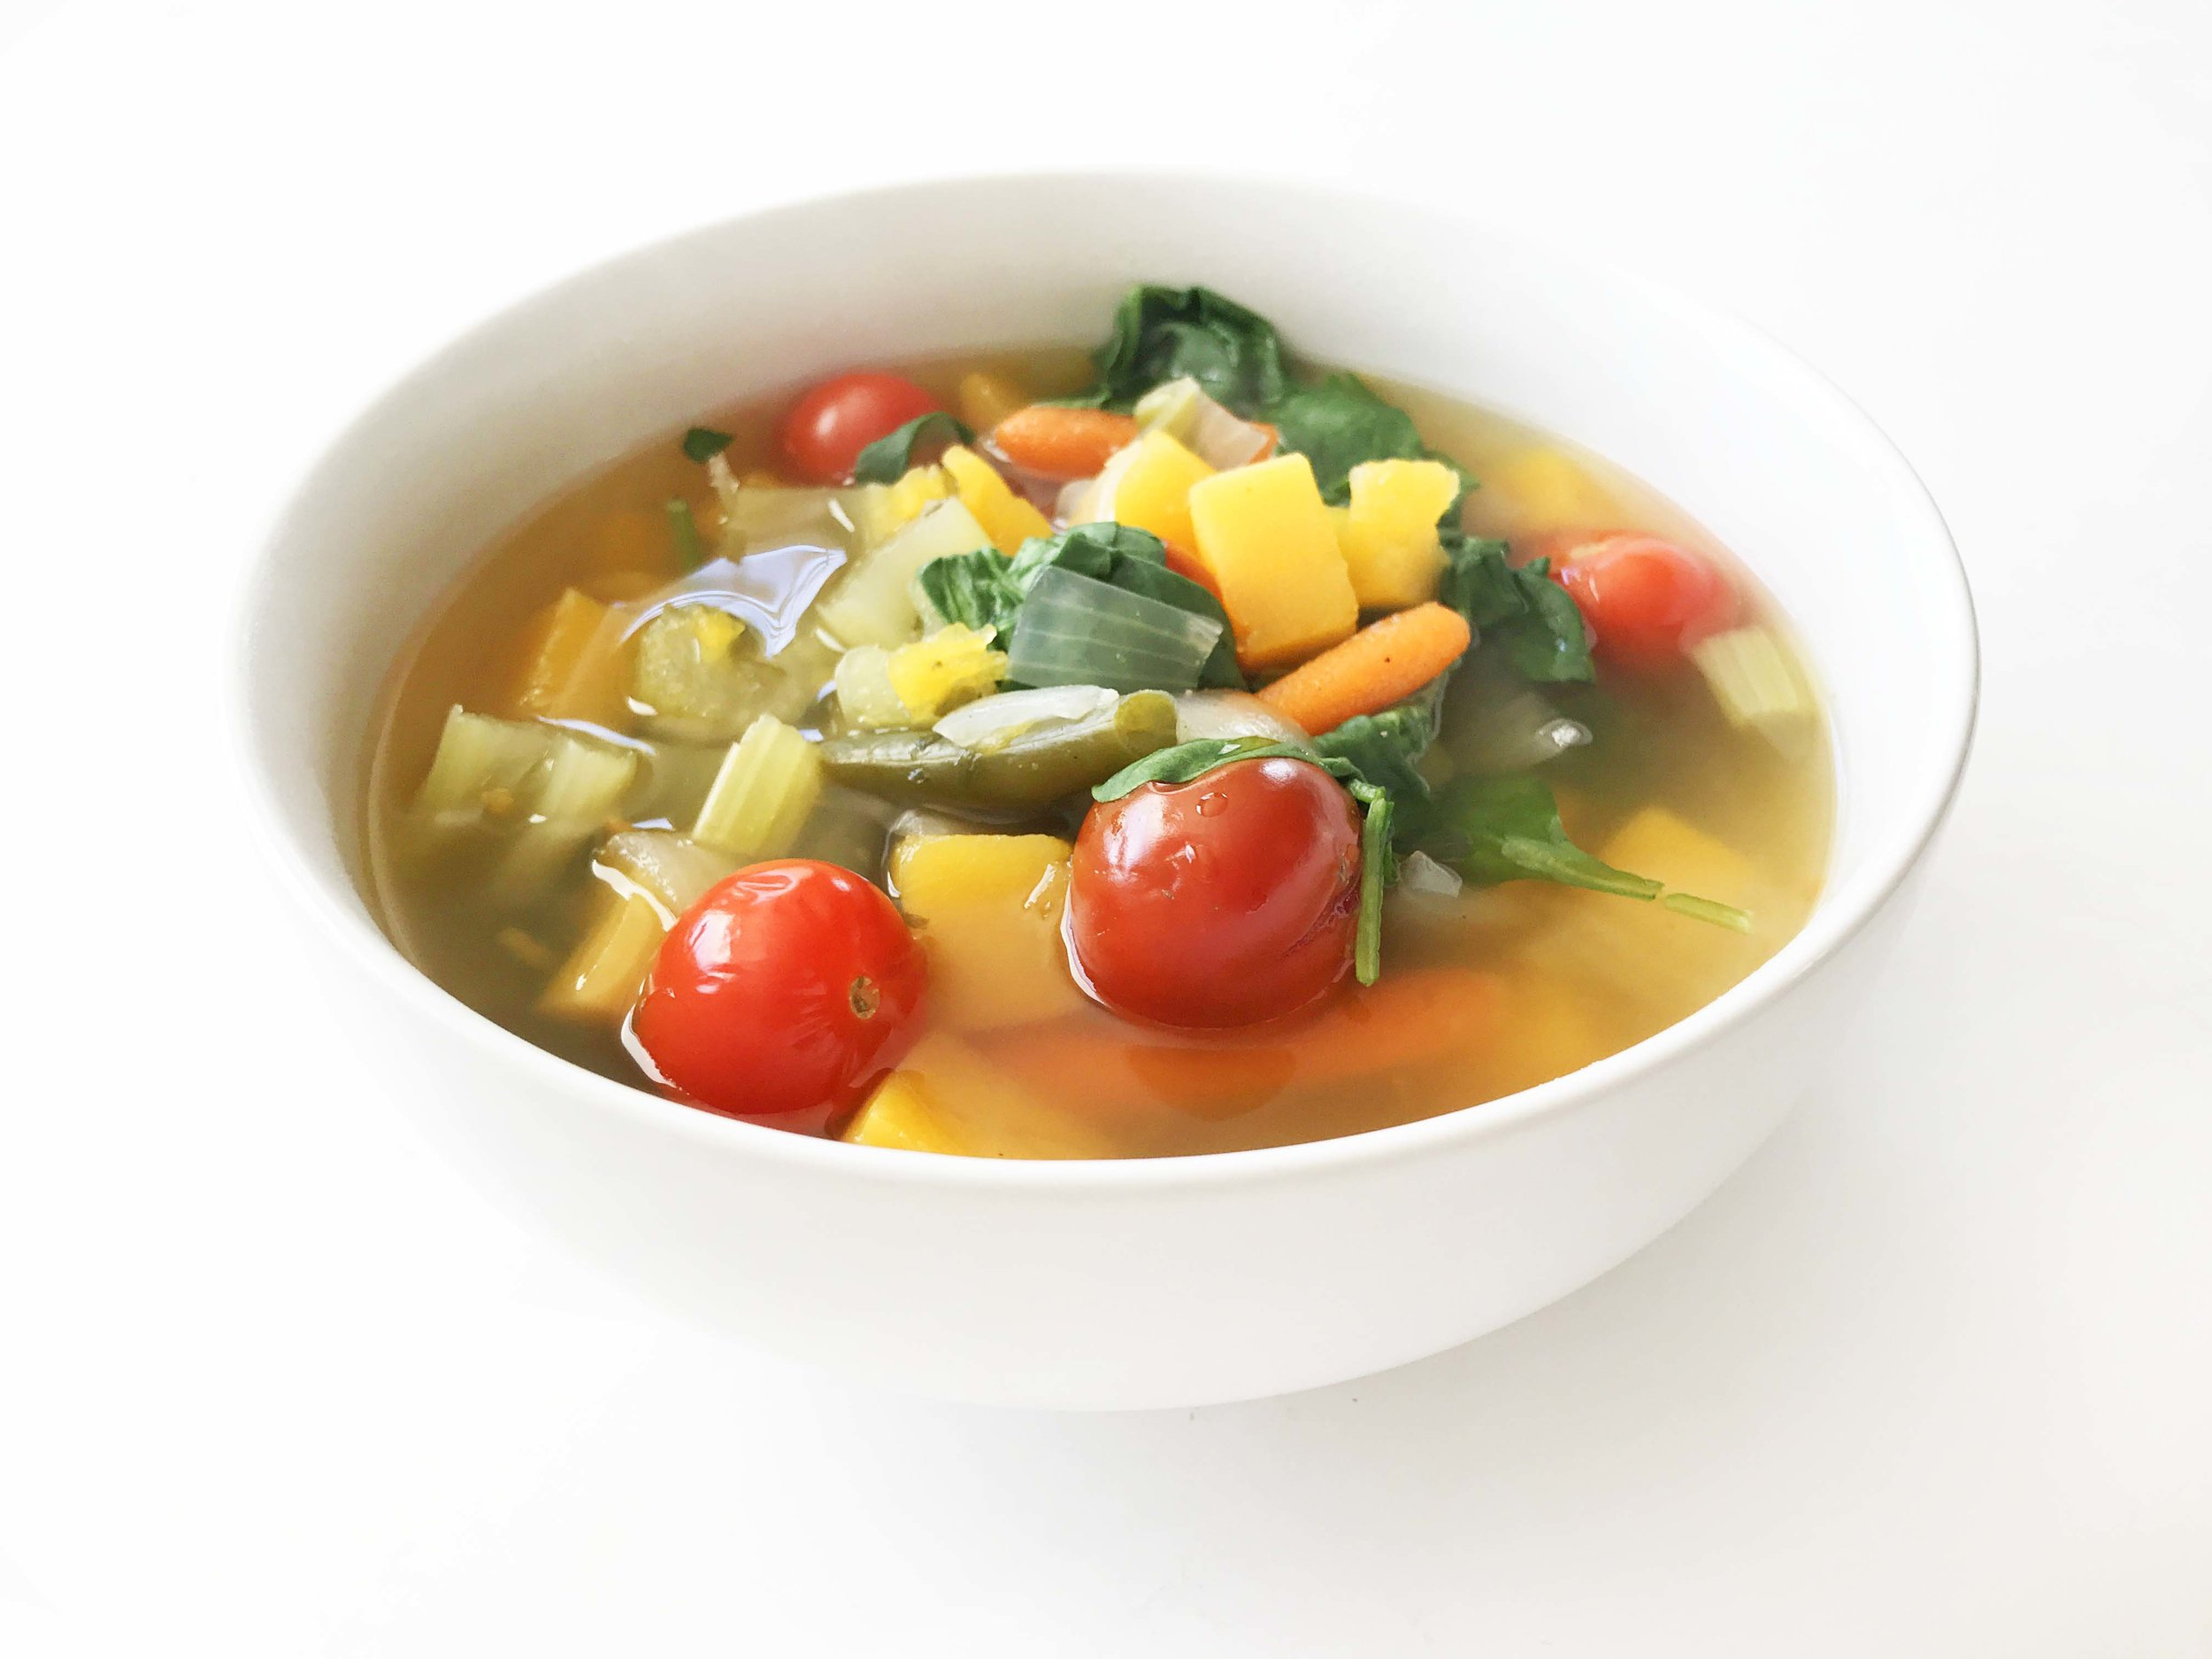 |  |  |  | Beef Stew  Fresh Bread  Salad
2 | 3 | 4 | 5 | 6 | 7 | 8
Ham  Mashed Potatoes  Beets | Cheeseburger  Fries  Coleslaw | Soup & Pie  Fundraiser  Supper 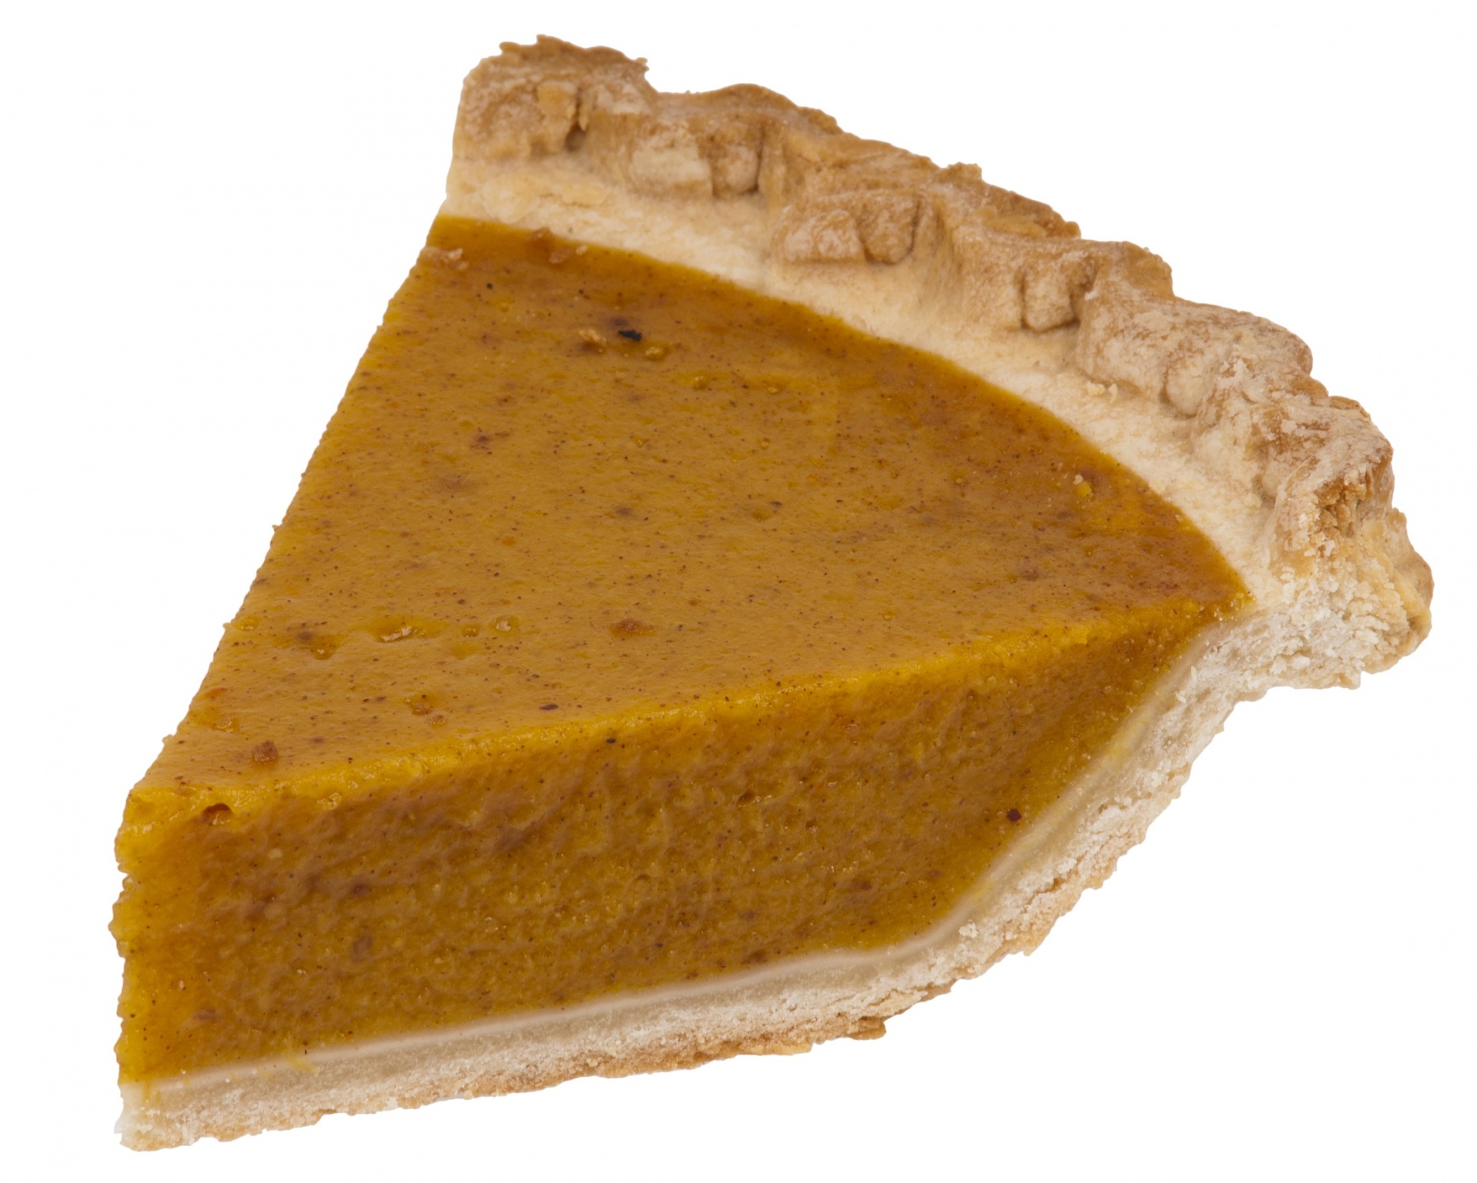 | BBQ Ribs  Baked potatoes  Coleslaw | Chicken Breast  Mashed potatoes  Carrots | Veal  Mashed Potatoes  Mixed Veggies | Rosemary Porklion  Mashed Potatoes  Green Beans
9 | 10 | 11 | 12 | 13 | 14 | 15
Spaghetti & Meatballs  Garlic bread | Turkey/ Mashed  Corn/ stuffing  Gravy cranberry sauce | Bone in Ham  Scalloped Potatoes  Carrots | Chef Salad  Turkey Soup | Enchiladas  Mexican Rice  Salad | Masala Beef Strip  Roast Potatoes  Veggies | Farmer Sausage  Kielke  Mix Veggies
16 | 17 | 18 | 19 | 20 | 21 | 22
S&S Meat balls  Rice  Green beans | Basa Fish  Fries  Coleslaw | KFC Chicken  Mashed Potatoes  Veggies | Ham with Apple Sauce  Mac & Cheese  Broccoli Salad | Shepherd Pie  Caesar Salad | Waffle Night  Strawberry Sauce  White Sauce  B-F Sausage | Pork Chops  Mashed Potatoes  Peas
23 | 24 | 25 | 26 | 27 | 28 | 29
Faspa  Pickles, Buns, Rolled Meat, Potato Salad | Cheese Manicotti  Sauce  Garden Salad | Beef Stir-Fry  Noodles | Fish Burger  Fries  Coleslaw | Honey Garlic  Chicken Balls  Fried Rice | Liver & Onions  Baked Potatoes  Veggies | Hamburger Steak  Mashed potatoes & gravy  Veggies
30 | 31
Chicken with Lemon  Caper sauce  Ranch potatoes  Veggies | Sloppy joes  Fries  Carrot Salad

