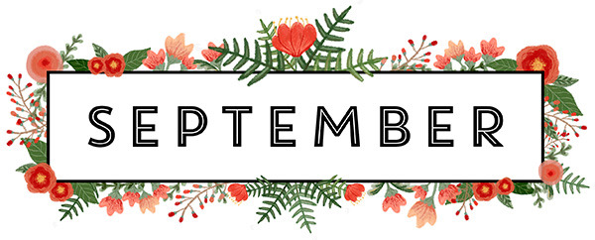 | 2022
Sunday | Monday | Tuesday | Wednesday | Thursday | Friday | Saturday
 |  |  |  | 1 | 2 | 3
 |  |  |  | Roast Beef  Mashed Potatoes  veggies | Basa Fish  Roasted Potatoes  coleslaw | Kielke  Farmer Sausage  veggies
4 | 5 | 6 | 7 | 8 | 9 | 10
Hot Beef Sandwich  Fries  Coleslaw | Ranch Chicken  Ranch Potatoes  Carrots | Ham  Mashed Potatoes  Apple Sauce  Mix veggies | Veal  Mashed Potatoes  Veggies | Honey Garlic Chicken  Stir-fry  Rice | Sloppy Joes  Fries  Cucumber Salad | Pork Shops  Mashed Potatoes  Green Beans
11 | 12 | 13 | 14 | 15 | 16 | 17
Pancakes  Bacon  Fruit | Sausage  Perogies w Gravy  Veggies | Fried fish  Rice  Corn Salad | Roast Chicken  Stuffing Mashed Potatoes w Veggies | Chef Salad  Big Bowl soup | Hamburger Steak  Mashed gravy  veggies | Ham  Scalloped Potatoes  Carrots
18 | 19 | 20 | 21 | 22 | 23 | 24
Chicken Lasagna  Cesar Salad | Creamy Garlic Shrimp  Rice with Veggies | Chicken Cordon bleu  Mashed Potatoes  Veggies | Beef Stroganoff  Noodles  Peas | Farmer Sausage  Back Beans  veggies | Ham Pineapple  Loaded Baked Potatoes  beets | Salmon Patty  Roast Potatoes  carrots
25 | 26 | 27 | 28 | 29 | 30
Chili  Fresh Bread  Salad | Chicken Parmesan  Noodle  Garlic Bread | Mushroom Meatballs  Mashed Potatoes  Green Beans | Fish Burgers  Fries  Coleslaw | Hawaiian Pork Chops  Rice  Veggies | Curry Chicken thighs  Roast Potatoes  Roast Veggies

